Medicare UI

Medicare LoginPage

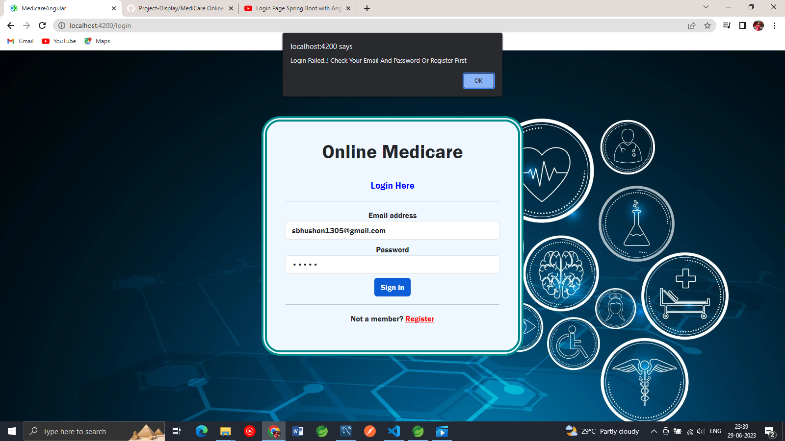

Registering first to get Enter

Email: [sbhushan1305@gmail.com](mailto:sbhushan1305@gmail.com)

Password : 12345

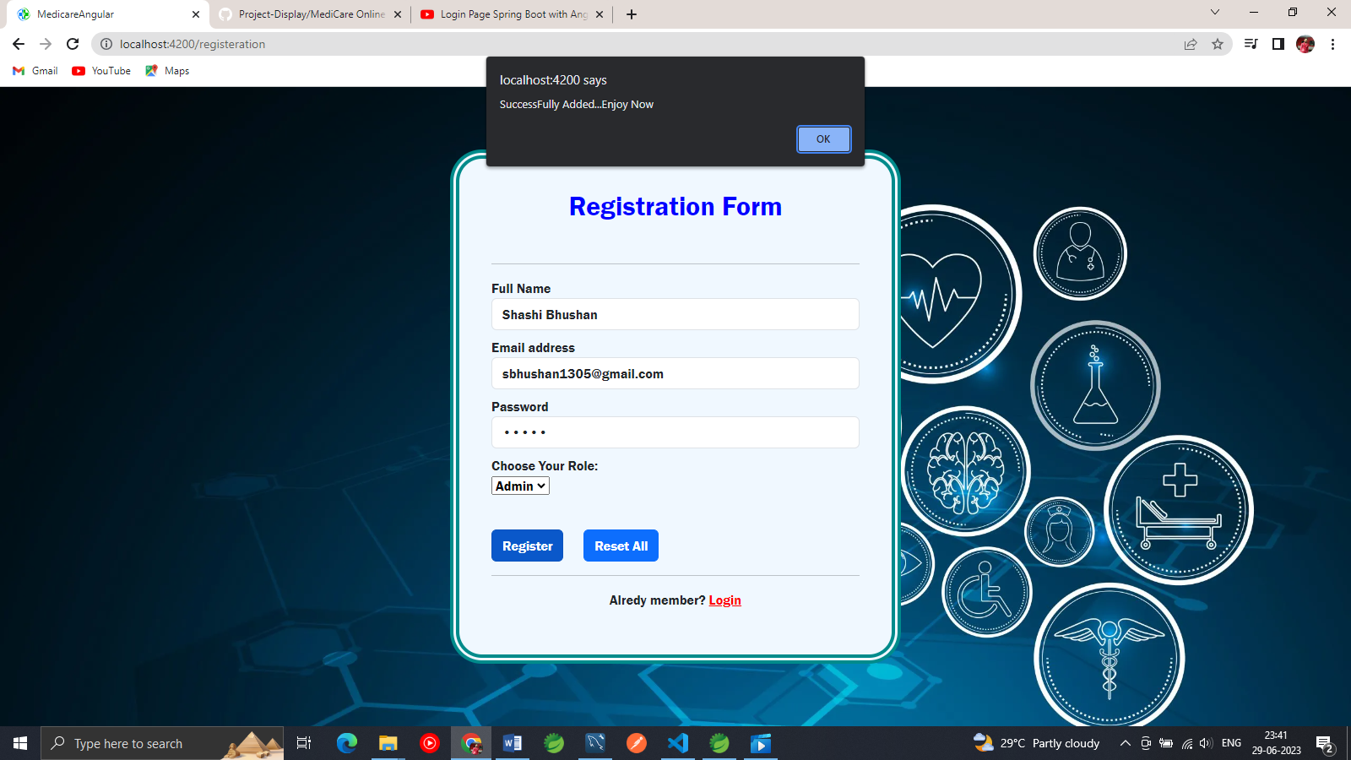

Save and secure in database

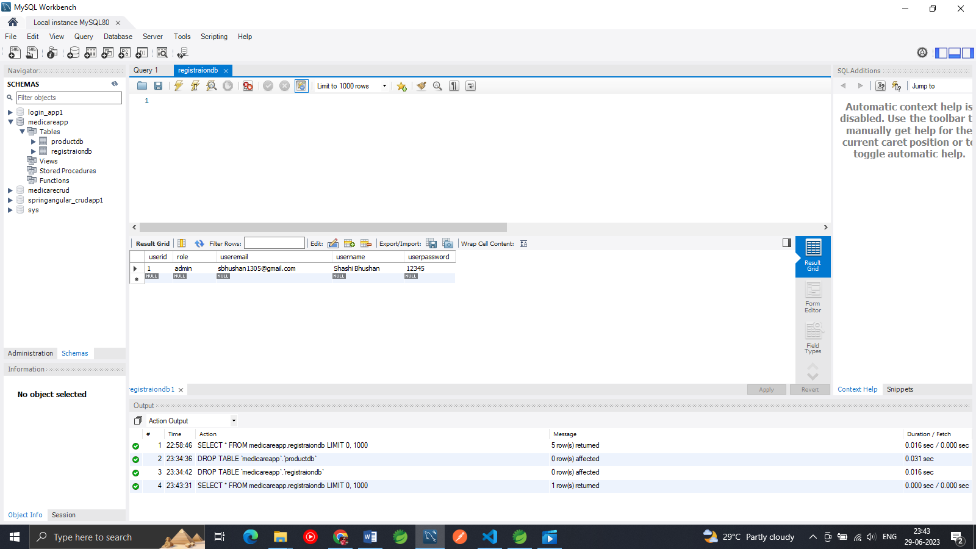

After login successfully with successful message. As soon click on ok will navigate to Home Page

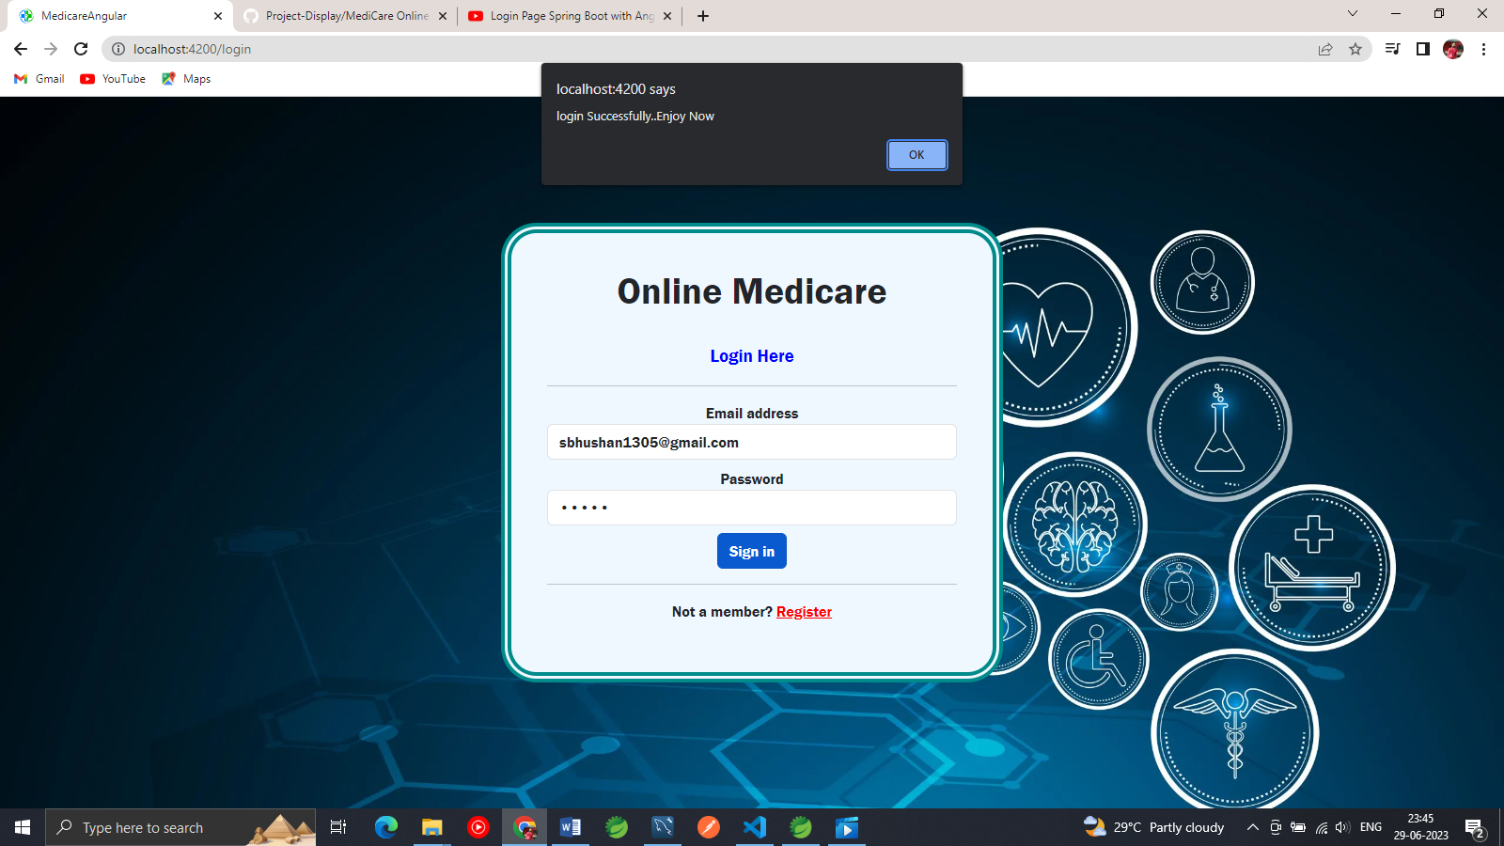

Navigate to Home page

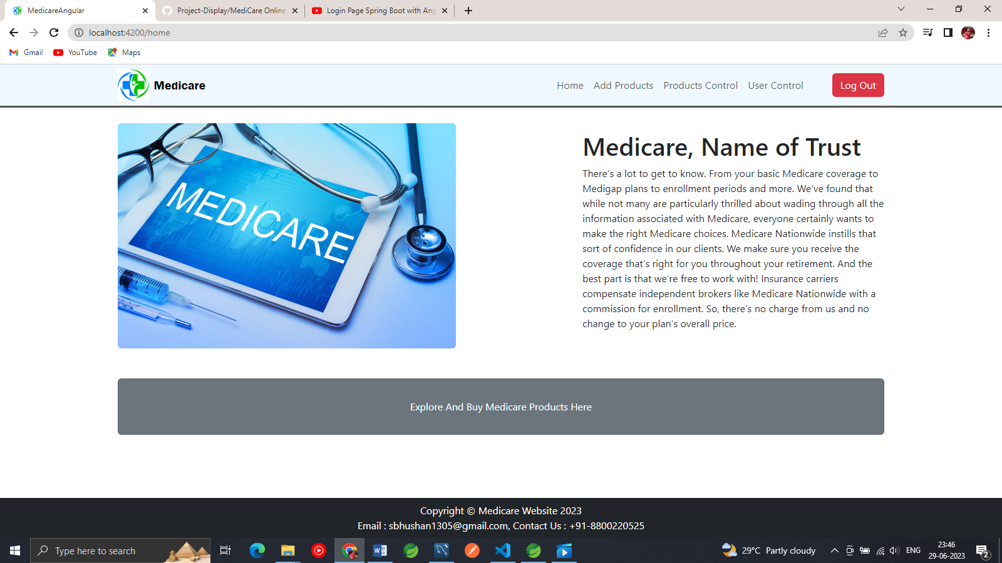

Add Product UI

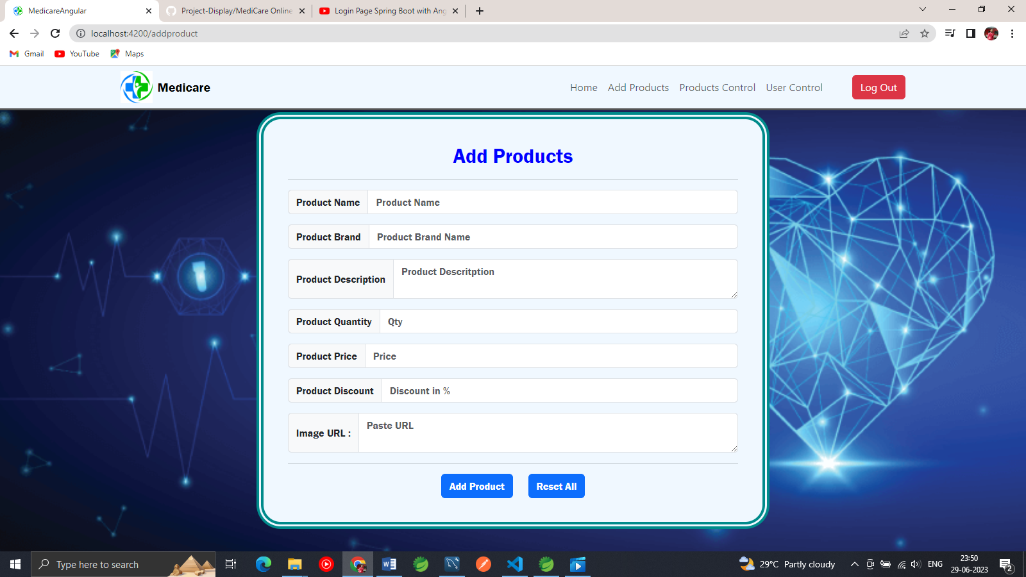

Data Added Sucessfully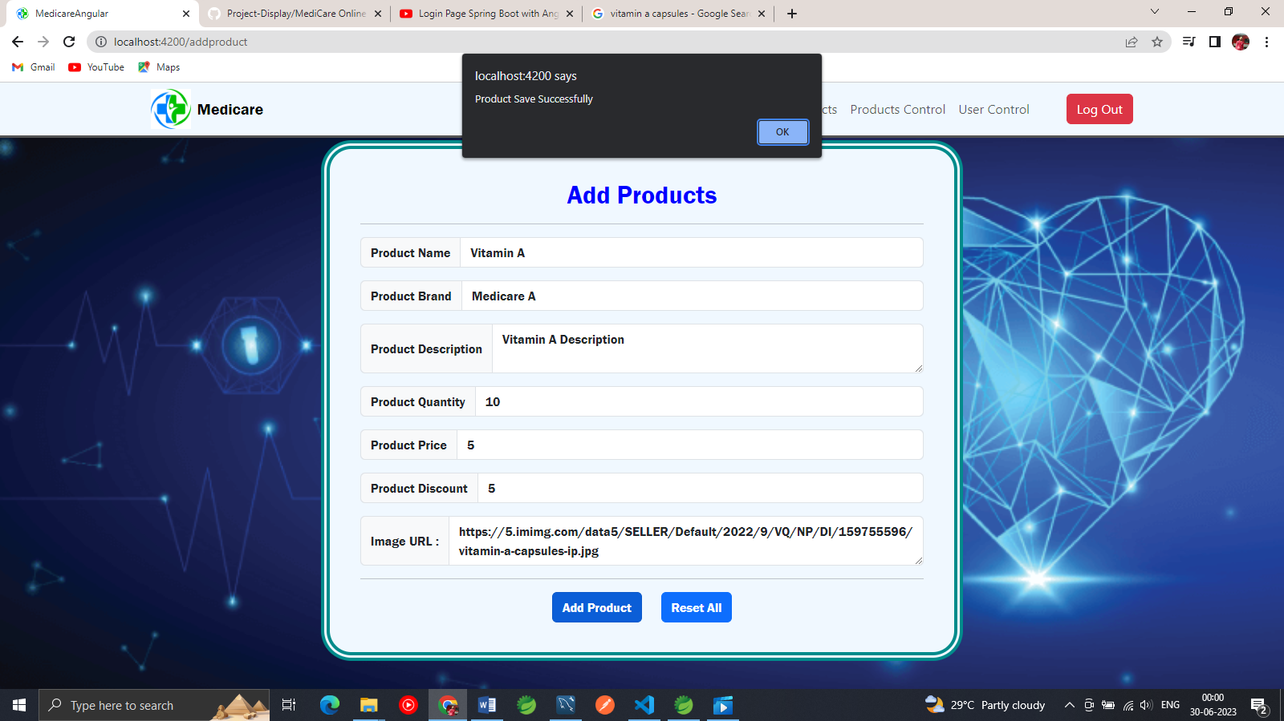

Product Added SuccessFully for user

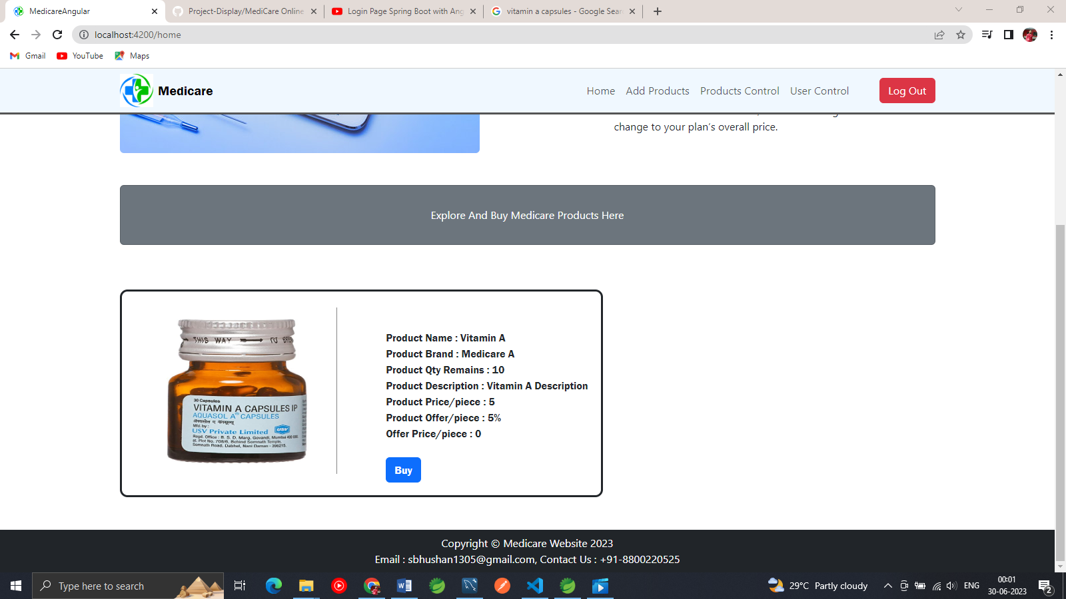

Product Added in Database successfully

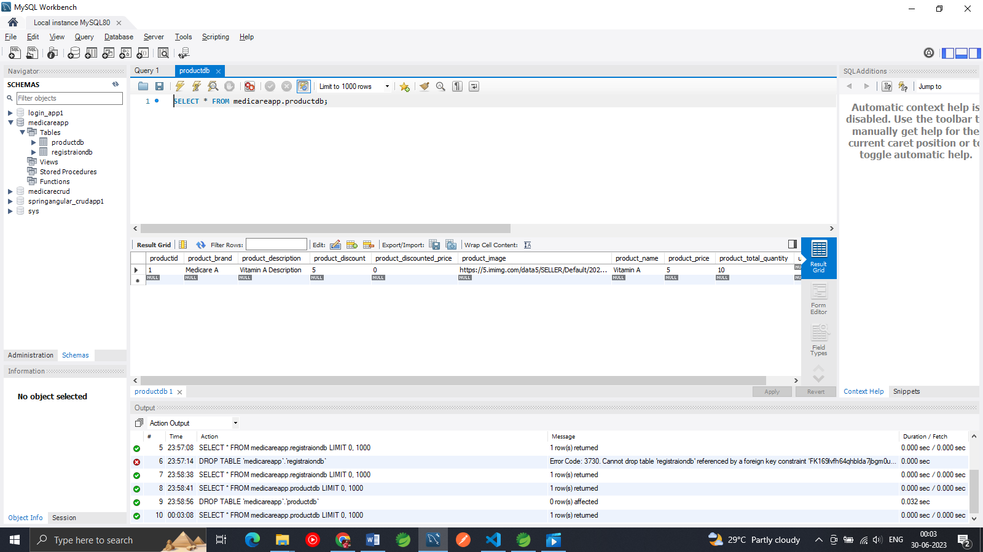

People can buy Product Now

